**Assignment -2**

Python-flask Programming

|  |  |
| --- | --- |
| Date | 19 September 2022 |
| Team ID | |  | | --- | | PNT2022TMID34044 | |
| Project Name | |  | | --- | | NewsTrackerApplication | |
| Maximum Marks | 2 Marks |

**Question-1:**

**Question-1:**

1. Create a Flask App

2. Add the Home page, About Page

3. Add the Bootstrap

|  |
| --- |
| 4.Add the Sign in page and App the Signup Page+ database connectivity |
| **app.py:**  from site import USER_BASE  from flask import Flask, render_template, url_for, request, redirect  import sqlite3 assql    app=Flask(__name__)  app.secret_key ='shreesathyam'  @app.route('/')  defhome():      con =sql.connect('user_base.db')      con.row_factory=sql.Row      cur=con.cursor()      cur.execute('select *from user')      users= cur.fetchall()      con.close()      returnrender_template('index.html',users=users)  @app.route('/about')  defabout():      returnrender_template('about.html')  @app.route('/signin')  defsignin():      returnrender_template('signin.html')  @app.route('/signup')  defsingup():      returnrender_template('signup.html')  @app.route('/user/<id>')  defuser_page(id):      withsql.connect('user_base.db') as con:          con.row_factory=sql.Row          cur =con.cursor()          cur.execute(f'SELECT * FROM user WHERE email="{id}"')          user = cur.fetchall()      returnrender_template("user_info.html", user=user[0])  @app.route('/accessbackend', methods=['POST','GET'])  defaccessbackend():      ifrequest.method == "POST":          try:              firstname=request.form['firstname']              lastname=request.form['lastname']              e_mail= request.form['email']              phone=request.form['phone']              password=request.form['password']              dob=request.form['dob']              withsql.connect('user_base.db') as con:                  cur =con.cursor()                  cur.execute('INSERT INTO user (firstname, lastname, email, phone, password, dob ) VALUES(?,?,?,?,?,?)', (str(firstname),str(lastname),str(e_mail),str(phone),str(password),str(dob)))                  con.commit()                  msg='u r resgistered!'            except:              con.rollback()              msg='some error'          finally:              print(msg)              return redirect(url_for('home'))      else:          try:              tue=request.args.get('email')              tup=request.args.get('password')              print(tue,tup)              withsql.connect('user_base.db') as con:                  con.row_factory=sql.Row                  cur=con.cursor()                  cur.execute(f'SELECT password FROM user WHERE email="{tue}"')                  user= cur.fetchall()          except:              print('error')              con.rollback()          finally:              iflen(user) >0:                  iftup == user[0][0]:                      return redirect(url_for("user_page",id=tue))                  print(user[0][0])              return redirect(url_for('signin')) |

About.html:

{% extends 'base.html '%}

{% block head %}

<title>abour page</title>

{% endblock%}

{%block body%}

<mainclass="container mx-auto my-4 bg-light border "style="width:60%;">

<h1class="p-2 border-bottom border-2">About page</h1>

<p>

    this flask app is developed for basic understandign of python-flask

</p>

<p>

    click <strong><ahref="/signup"class=" btnbtn-outline-success py-1">signup</a></strong> and <strong><ahref="/signin"class=" btnbtn-outline-success py-1">signin</a></strong> in the nav bar

</p>

</h1></main>

{% endblock%}

Base.html

<!DOCTYPEhtml>

<htmllang="en">

    <head>

        <metacharset="utf-8">

        <metaname="viewport"content="width=device-width, initial-scale=1">

<linkhref="https://cdn.jsdelivr.net/npm/bootstrap@5.0.2/dist/css/bootstrap.min.css"rel="stylesheet"integrity="sha384-EVSTQN3/azprG1Anm3QDgpJLIm9Nao0Yz1ztcQTwFspd3yD65VohhpuuCOmLASjC"crossorigin="anonymous">

<scriptsrc="https://cdn.jsdelivr.net/npm/bootstrap@5.0.2/dist/js/bootstrap.bundle.min.js"integrity="sha384-MrcW6ZMFYlzcLA8Nl+NtUVF0sA7MsXsP1UyJoMp4YLEuNSfAP+JcXn/tWtIaxVXM"crossorigin="anonymous"></script>

<!--<link rel="stylesheet" href="{{url_for('static', filename='css/style.css')}}"> -->

{% block head%}{% endblock %}

</head>

<bodystyle="background: linear-gradient(70deg, blue 10%, pink);">

    <navclass="navbarnavbar-expand-lgnavbar-light bg-light">

        <divclass="container-fluid">

          <aclass="navbar-brand"href="#">Navbar</a>

          <buttonclass="navbar-toggler"type="button"data-bs-toggle="collapse"data-bs-target="#navbarSupportedContent"aria-controls="navbarSupportedContent"aria-expanded="false"aria-label="Toggle navigation">

            <spanclass="navbar-toggler-icon"></span>

          </button>

          <divclass="collapse navbar-collapse"id="navbarSupportedContent">

            <ulclass="navbar-nav me-auto mb-2 mb-lg-0">

              <liclass="nav-item">

                <aclass="nav-link active"aria-current="page"href="/">Home</a>

              </li>

              <liclass="nav-item">

                <aclass="nav-link"href="/signin">signin</a>

              </li>

              <liclass="nav-item">

                <aclass="nav-link"href="/signup">signup</a>

              </li>

              <liclass="nav-item">

                <aclass="nav-link"href="/about">about</a>

              </li>

              <liclass="nav-item dropdown">

                <aclass="nav-link dropdown-toggle"href="#"id="navbarDropdown"role="button"data-bs-toggle="dropdown"aria-expanded="false">

                  Dropdown

                </a>

                <ulclass="dropdown-menu"aria-labelledby="navbarDropdown">

                  <li><aclass="dropdown-item"href="#">Action</a></li>

                  <li><aclass="dropdown-item"href="#">Another action</a></li>

                  <li><hrclass="dropdown-divider"></li>

                  <li><aclass="dropdown-item"href="#">Something else here</a></li>

                </ul>

              </li>

            </ul>

            <formclass="d-flex">

              <inputclass="form-control me-2"type="search"placeholder="Search"aria-label="Search">

              <buttonclass="btnbtn-outline-success"type="submit">Search</button>

            </form>

          </div>

        </div>

      </nav>

    <divclass="container mt-5">

        {% block body %} {% endblock %}

    </div>

</body>

</html>

Index.html

{% extends 'base.html '%}

{% block head %}

<title>home page</title>

{% endblock%}

{%block body%}

<mainclass="container mx-auto my-4 bg-light border border-2"style="width: 70%;">

<divclass="p-4">

   <h1>Welcome to the flask app</h1>

    <h2>register user list </h2>

    <div>{% for user in users%}

        <div   style="background: linear-gradient(to top,rgb(51,204,255), 20%, cyan);"class="border rounded fs-4 p-1 px-2 mb-3"style="width: 40%;">

            {{ user["firstname"] + " " +user['lastname'] }}

        </div>

        {% endfor %}

    </div>

</div>

</main>

{% endblock%}

Signin.html

{% extends 'base.html '%}

{% block head %}

<title>Sigin page</title>

{% endblock%}

{%block body%}

<mainclass="container">

    <divclass="mx-auto mt-5 border bg-light"style="width:500px;">

    <h2class='mx-4 mt-2'>SINGIN</h2>

    <formaction="{{url_for('accessbackend') }}"method="get">

        <divclass="my-2 mx-4">

            <labelfor="email">Email</label>

            <inputtype="email"class="form-control"placeholder="adc@gmail.com"name="email"required/>

        </div>

        <divclass="my-2 mx-4">

            <labelfor="password">password</label>

            <inputtype="password"class="form-control"  name="password"required/>

        </div>

        <inputtype="submit"value="submit"class="btnbtn-primary my-4 mt-2 "/>

    </form></div>

</main>

{% endblock%}

Signup:

{% extends 'base.html '%}

{% block head %}

<title>Signup page</title>

{% endblock%}

{%block body%}<mainclass="container">

    <divclass="mx-auto mt-5 border bg-light"style="width: 500px;">

    <h2class="mx-4 mt-2">SIGNUP</h2>

    <formaction="{{url_for('accessbackend') }}"method="post">

        <divclass="my-2 mx-4">

            <labelfor="firstname">first name</label>

            <inputtype="text"class="form-control"placeholder="Ram"name="firstname"required/>

        </div>

        <divclass="my-2 mx-4">

            <labelfor="lastname">last name</label>

            <inputtype="text"class="form-control"placeholder="kumar"name="lastname"required/>

        </div>

        <divclass="my-2 mx-4">

            <labelfor="email">email</label>

            <inputtype="text"class="form-control"placeholder="abc@gmail.com"name="email"required/>

        </div>

        <divclass="my-2 mx-4">

            <labelfor="phone">phone</label>

            <inputtype="text"class="form-control"placeholder="0987654321"name="phone"required/>

        </div>

        <divclass="my-2 mx-4">

            <labelfor="password">password</label>

            <inputtype="password"class="form-control"placeholder="password"name="password"required/>

        </div>

        <divclass="my-2 mx-4">

            <labelfor="dob">date of brith</label>

            <inputtype="date"class="form-control"name="dob"required/>

        </div>

        <inputtype="submit"value="submit"class="btnbtn-primary my-4 my-2 mt-2"/>

    </form>

    </div>

</main>

{% endblock%}

Information database:

{% extends 'base.html '%}

{% block head %}

<title>home page</title>

{% endblock%}

{%block body%}

<mainclass="container mx-auto my-4 bg-light border"style="width:70%;">

<divclass="p-4">

    <h2>{{ user[0] +" " + user[1]}}</h2>

    <divclass="border rounded fs-5 p-1 px-5 mb-3"style="width: 60%;">

        <spanstyle="display: block;">first name:{{user[0]}}</span>

        <spanstyle="display: block;">last name:{{user[1]}}</span>

        <spanstyle="display: block;">email:{{user[2]}}</span>

        <spanstyle="display: block;">phone:{{user[3]}}</span>

        <spanstyle="display: block;">date of brith:{{user[5 ]}}</span>

    </div>

</div></main>

{% endblock%}

Database setup:

import sqlite3

conn =sqlite3.connect('user_base.db')

print('successfully database opened')

conn.execute(' CREATE TABLE user(firstname TEXT, lastname TEXT, email TEXT, phone TEXT, password TEXT, dob TEXT );')

print("table created")

conn.close()

output:

Signup: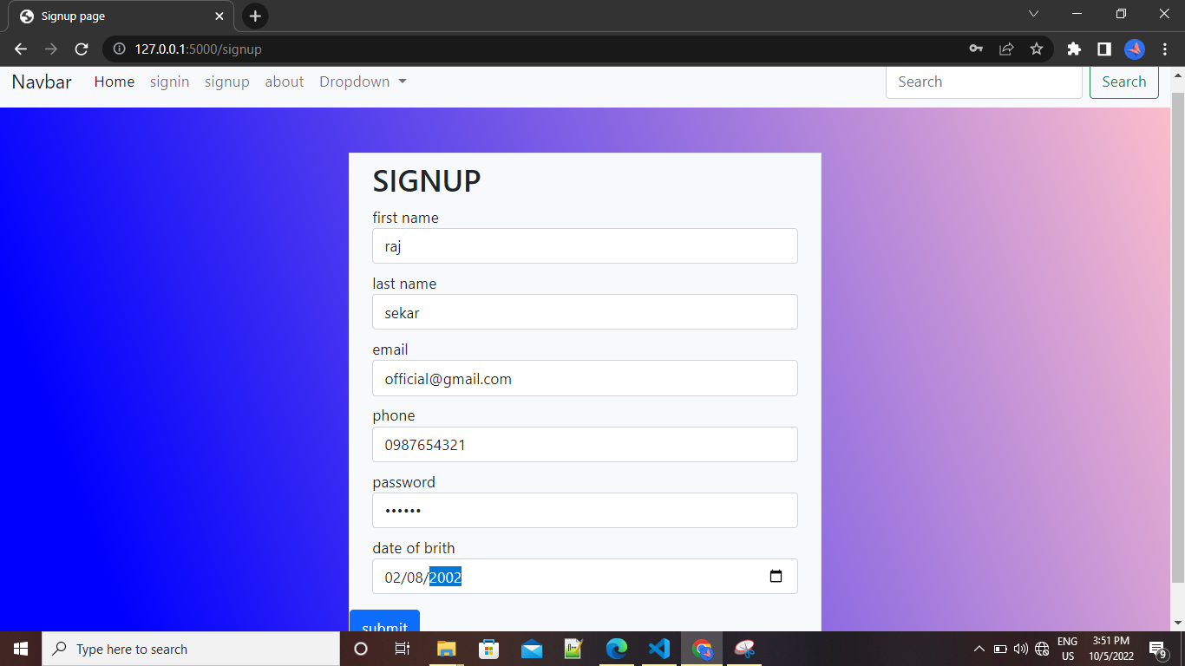

Singin:pagdsfsdsfsda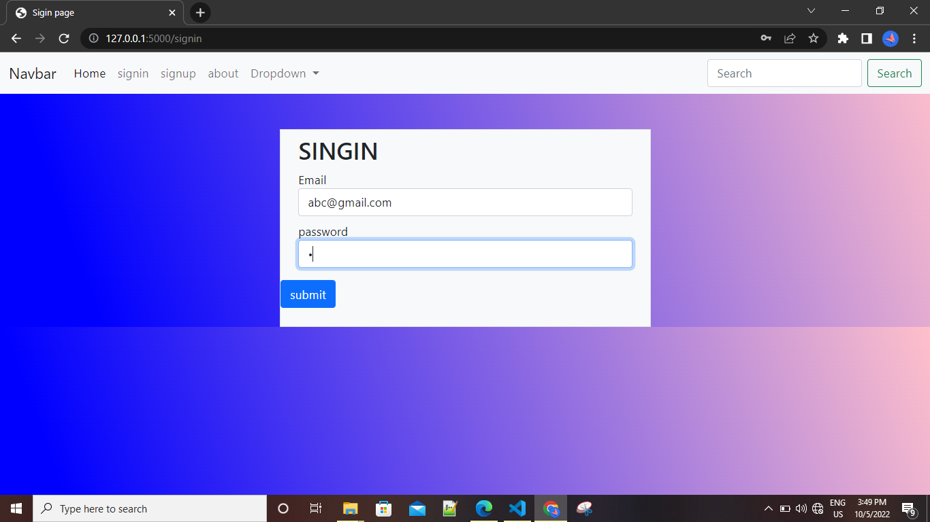

About:

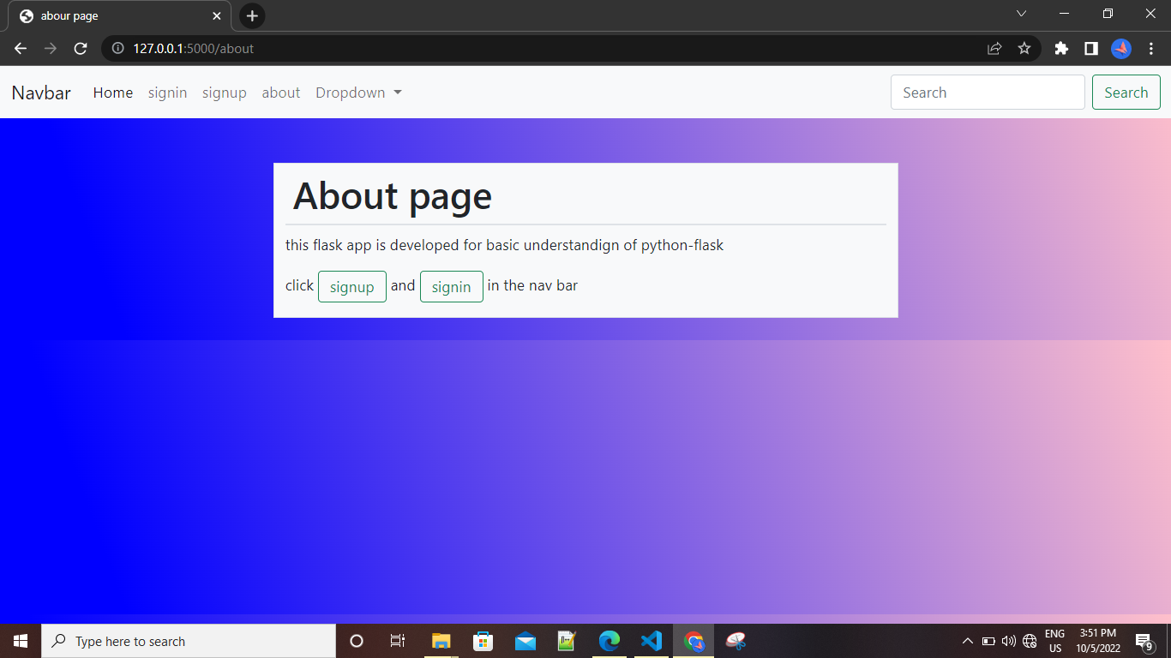

Home page:

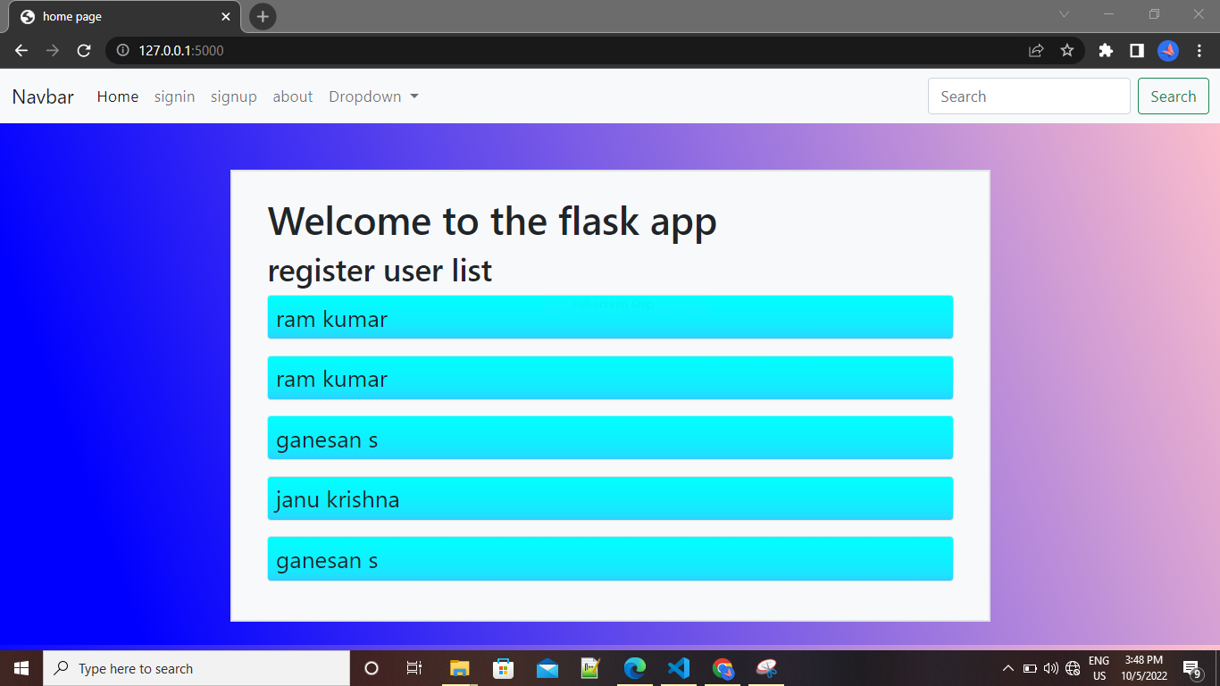

Database connectivity: